Following the Faithful
Elizabeth & Zechariah
December 2, 2018

Chris Stull, Pastor
For nothing will be impossible with God.
Luke 1:37
Lessons in Obedience:
- Daily obedience is obedience
- Obeying God for He is
- Trust & obedience in the does not the same in the
- God is more with the obedient than the
Lessons in Faith/Trust:
- to others faith
- God & everyday faithfulness
- God more to those who more
Steps on the Journey = & :
- The of a son
- Steps of faith sometimes us to others in order to God
- John = God is
Following the Faithful
Elizabeth & Zechariah
December 2, 2018

Chris Stull, Pastor
For nothing will be impossible with God.
Luke 1:37
Lessons in Obedience:
- Daily obedience is obedience
- Obeying God for He is
- Trust & obedience in the does not the same in the
- God is more with the obedient than the
Lessons in Faith/Trust:
- to others faith
- God & everyday faithfulness
- God more to those who more
Steps on the Journey = & :
- The of a son
- Steps of faith sometimes us to others in order to God
- John = God is
What’s Up @ Wellspring . . .
December 2 Soup & Snowflakes. Wellspring Women Luncheon & Ornament Exchange @12:30 pm @ the Stull’s home
January 18-20 SAVE THE DATE for Disciple Now. A local retreat for 6th-12th grade students. Cost is $40. Registration will start in the weeks to come!

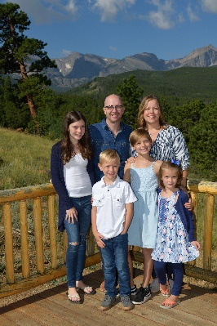
Wellspring is excited to welcome the Dodridge family!
Brian will be joining our pastoral staff, assisting Pastor Chris and working alongside our staff and volunteer teams. Brian and Deanna, both Arizona natives, will be bringing their four children to join us in January. The Dodridge's will be coming from Tennessee and we anticipate serving Wellspring and the West Valley with them.

What’s Up @ Wellspring . . .
December 2 Soup & Snowflakes. Wellspring Women Luncheon & Ornament Exchange @12:30 pm @ the Stull’s home
January 18-20 SAVE THE DATE for Disciple Now. A local retreat for 6th-12th grade students. Cost is $40. Registration will start in the weeks to come!

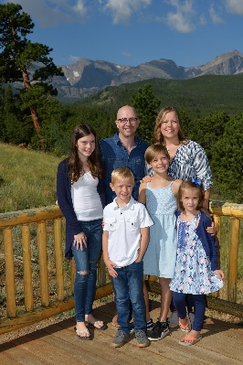
Wellspring is excited to welcome the Dodridge family!
Brian will be joining our pastoral staff, assisting Pastor Chris and working alongside our staff and volunteer teams. Brian and Deanna, both Arizona natives, will be bringing their four children to join us in January. The Dodridge's will be coming from Tennessee and we anticipate serving Wellspring and the West Valley with them.

