Follow Me
Making Disciples Like Jesus
October 21, 2018
Cameron Ford

Chris Stull, Pastor
Then Jesus came to them and said, “All authority in heaven and on earth has been given to me. Therefore go and make disciples of all nations, baptizing them in the name of the Father and of the Son and of the Holy Spirit, and teaching them to obey everything I have commanded you. And surely I am with you always, to the very end of the age.”
Matthew 28:18-20 NIV

Phases of Spiritual Growth:
Dead Born Again Infant Child Young Adult Parent

How Jesus made disciples:
- Jesus modeled with the spiritually dead and the spiritual infant. (John 4)
- Jesus modeled helping spiritual children relationally to God and other disciples. (Mark 12:29-31)
- Jesus equipped spiritual young adults to to others. (John 6:1-13)
- Jesus modeled sending out spiritual parents to intentionally others. (Luke 10:1-12)

Follow Me
Making Disciples Like Jesus
October 21, 2018
Cameron Ford

Chris Stull, Pastor
Then Jesus came to them and said, “All authority in heaven and on earth has been given to me. Therefore go and make disciples of all nations, baptizing them in the name of the Father and of the Son and of the Holy Spirit, and teaching them to obey everything I have commanded you. And surely I am with you always, to the very end of the age.”
Matthew 28:18-20 NIV

Phases of Spiritual Growth:
Dead Born Again Infant Child Young Adult Parent

How Jesus made disciples:
- Jesus modeled with the spiritually dead and the spiritual infant. (John 4)
- Jesus modeled helping spiritual children relationally to God and other disciples. (Mark 12:29-31)
- Jesus equipped spiritual young adults to to others. (John 6:1-13)
- Jesus modeled sending out spiritual parents to intentionally others. (Luke 10:1-12)
What’s Up @ Wellspring . . .
October 21 Pizza with the Pastor
November 4 Baptism
Elder Reception
November 4 & 11 Operation Christmas Child Box Distribution
November 18 Operation Christmas Child Boxes Due
January 18-20 SAVE THE DATE for Disciple Now. A local retreat for 6th-12th grade students. Cost is $40. Registration will start in the weeks to come!
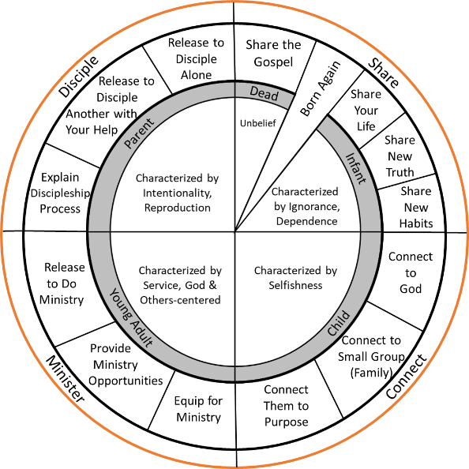

What’s Up @ Wellspring . . .
October 21 Pizza with the Pastor
November 4 Baptism
Elder Reception
November 4 & 11 Operation Christmas Child Box Distribution
November 18 Operation Christmas Child Boxes Due
January 18-20 SAVE THE DATE for Disciple Now. A local retreat for 6th-12th grade students. Cost is $40. Registration will start in the weeks to come!

