Follow Me
Love in Action . . . Walk Like Jesus
October 14, 2018

Chris Stull, Pastor
You then, my son, be strong in the grace that is in Christ Jesus. And the things you have heard me say in the presence of many witnesses entrust to reliable people who will also be qualified to teach others.
2 Timothy 2:1-2 NIV
Ways to Walk Like Jesus Walked:
- Be connected in a & vibrant environment

- Accountability and
- Environment
- Experience real that involves real
- disciples

- in action
No one is useless in this world who lightens the burdens of another.

CHARLES DICKENS
No one is useless in this world who lightens the burdens of another.

CHARLES DICKENS

Follow Me
Love in Action . . . Walk Like Jesus
October 14, 2018

Chris Stull, Pastor
You then, my son, be strong in the grace that is in Christ Jesus. And the things you have heard me say in the presence of many witnesses entrust to reliable people who will also be qualified to teach others.
2 Timothy 2:1-2 NIV
Ways to Walk Like Jesus Walked:
- Be connected in a & vibrant environment

- Accountability and
- Environment
- Experience real that involves real
- disciples

- in action
No one is useless in this world who lightens the burdens of another.

CHARLES DICKENS

What’s Up @ Wellspring . . .
October 21 Pizza with the Pastor
November 4 Baptism
January 18-20 SAVE THE DATE for Disciple Now. A local retreat for 6th-12th grade students. Cost is $40. Registration will start in the weeks to come!

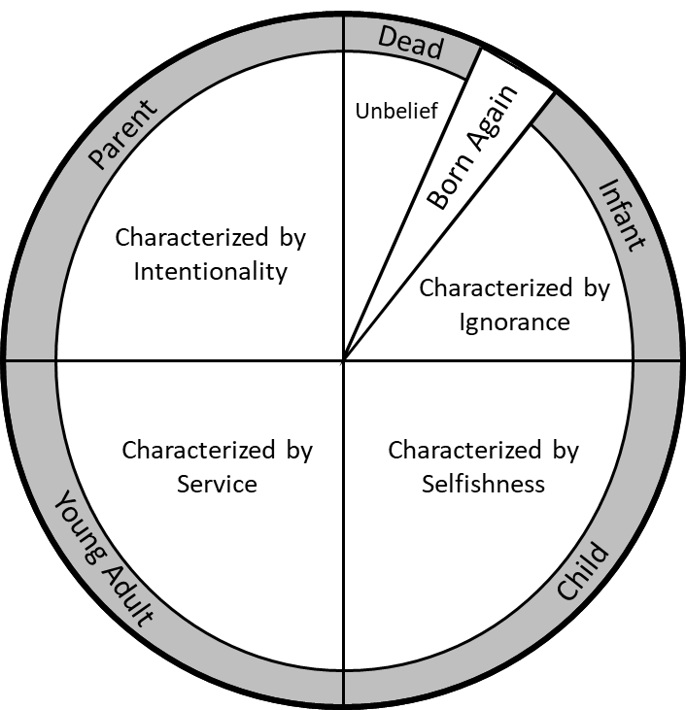

What’s Up @ Wellspring . . .
October 21 Pizza with the Pastor
November 4 Baptism
January 18-20 SAVE THE DATE for Disciple Now. A local retreat for 6th-12th grade students. Cost is $40. Registration will start in the weeks to come!

