Follow Me
Keys to Making Disciples
September 30, 2018

Chris Stull, Pastor
And He said to them, “Follow Me, and I will make you fishers of men.” Matthew 4:19 NASB
3 Keys to Making Disciples:
- leadership (the )
- environment (the )

- process ( / )
+ + +

Follow Me
Keys to Making Disciples
September 30, 2018

Chris Stull, Pastor
And He said to them, “Follow Me, and I will make you fishers of men.” Matthew 4:19 NASB
3 Keys to Making Disciples:
- leadership (the )
- environment (the )

- process ( / )
+ + +

What’s Up @ Wellspring . . .
September 30 New Membership Class
October 10 Wellspring Women host The Pink Project - A night of service with a mission to comfort those on a cancer journey on Wednesday, October 10 from 6:30 – 8:30 pm at Palm Valley Community Center (14145 W. Palm Valley Blvd., Goodyear, AZ 85395)

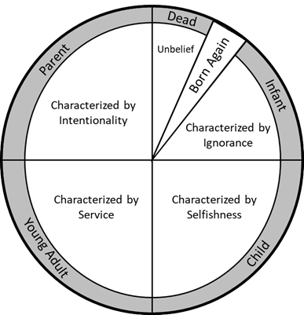

What’s Up @ Wellspring . . .
September 30 New Membership Class
October 10 Wellspring Women host The Pink Project - A night of service with a mission to comfort those on a cancer journey on Wednesday, October 10 from 6:30 – 8:30 pm at Palm Valley Community Center (14145 W. Palm Valley Blvd., Goodyear, AZ 85395)

